- PERSONAL INFORMATION
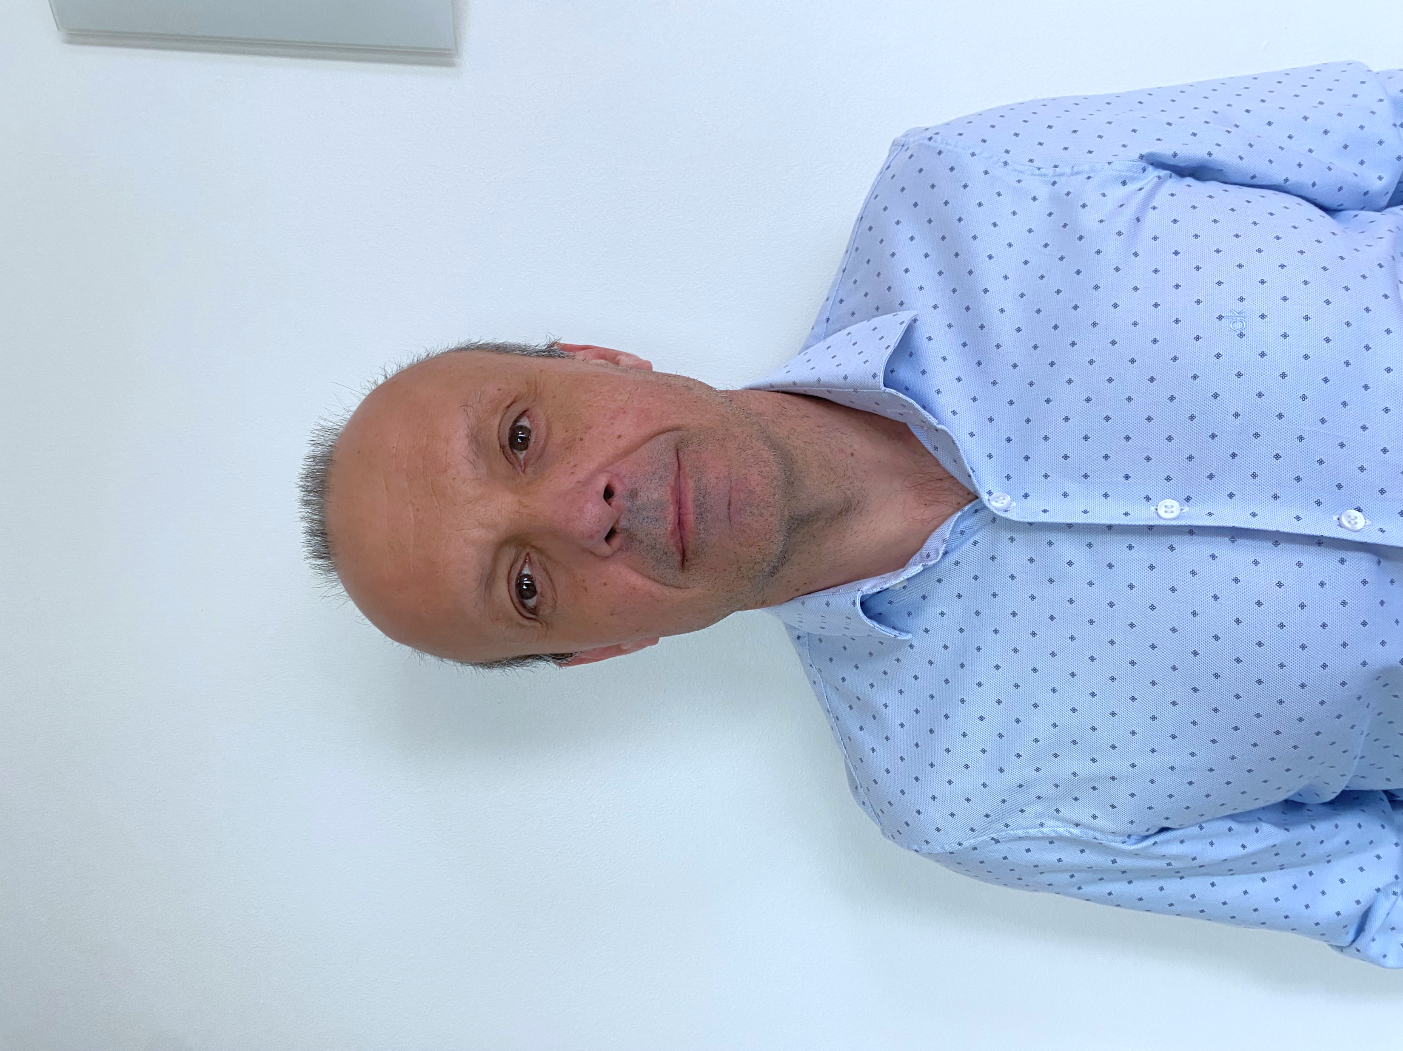
Name: François Ganachaud
ORCID Researcher unique identifier(s): 0000-0003-2658-2734
Date of birth: 14 June 1969
Nationality: French
Bibliometrics: http://scholar.google.com/citations?user=8E_t5q4AAAAJ&hl=en&oi=ao
Publications (05-12-2023): 112 peered articles (not including abstracts), h-index 38, 5340 citations (Scopus), 8 book chapters, 21 patents (Espacenet).

- EDUCATION

2003 Habilitation to supervise PhDs, Montpellier Uni./ICGM/Montpellier, France
1997 Ph. D (with the highest rank for only 15% of awarded PhD), Claude Bernard University/Mix unit CNRS-Biomérieux, Lyon, France

- POSITIONS

2020 – Research Director, IMP laboratory, University of Lyon, Villeurbanne, France
2018 – 2019 Research Director, COMPASS Lab, CNRS / SOLVAY/ UPenn University, Philadelphia, USA
2012 – 2018 Research Director, IMP laboratory, University of Lyon, Villeurbanne, France
2011 – 2012 Research Fellows, IMP laboratory, University of Lyon, Villeurbanne, France
2003 – 2011 Research Fellows, ICGM institute, School of Chemistry, Montpellier, France
1999 – 2003 Research Fellows, LCM, Jussieu University, Paris, France
1998 Post-Doctorate fellow, KCPC, Sydney, Australia with Prof. Robert G. Gilbert

- FELLOWSHIPS AND AWARDS

2018 – 2019 CNRS Fellowship for delegation in an International Joint Lab (COMPASS, USA)
2012 – 2018 CNRS Award for excellence in Teaching and Research (gratification)
Granted for 4 years, renewed in 2016
2004 – 2007 Young researcher CNRS Fellowship ATIP (2 years post-doc funding)

- SUPERVISION OF GRADUATE STUDENTS AND POSTDOCTORAL FELLOWS

I have mentored 25 PhDs and 17 post-docs. I have been a member of around 30 external PhDs juries and one Habilitation jury. I am currently (co-)advising 4 PhDs and one post-doc.

- TEACHING ACTIVITIES

2012 – INSA-Lyon, Villeurbanne, France
6h/year of Master courses on silicone polymers
60h/year of practical work on polymer material processing and characterization
About 10h per year on adult masterclass on silicones (on the flow)
2003 – 2011 School of chemistry, Montpellier, France:
15 hours/year of lectures around polymer and aqueous dispersions
30 hours/year of practical work on emulsion polymerization

- ORGANISATION OF SCIENTIFIC MEETINGS

I have organized twice the most important international workshop in the field of silicones (called ISPO), in 2007 and 2014 in Mèzes and Aussois, respectively (France). More than 100 attendees from industry and academia gathered into this polymer-specific events. In 2019, I co-organized with Prof. R. Priestley and Prof. R. Prud’homme (Princeton) a special ACS Fall session in San Diego on “Emulsification and Encapsulation by Soft Matter Techniques”.

- INSTITUTIONAL RESPONSIBILITIES

2021 – Co-leader of the chemistry team of IMP lab, about 30 permanent researchers
2015 – 2018 Scientific coordinator of the NMR team of Lyon Chemistry Institute (located at IMP).

- MEMBERSHIPS OF SCIENTIFIC SOCIETIES

2018 – 2019 ACS Member, USA.
2000 – International Polymer Colloid Group, USA.
1999 – French Group of Polymer (GFP), France.

